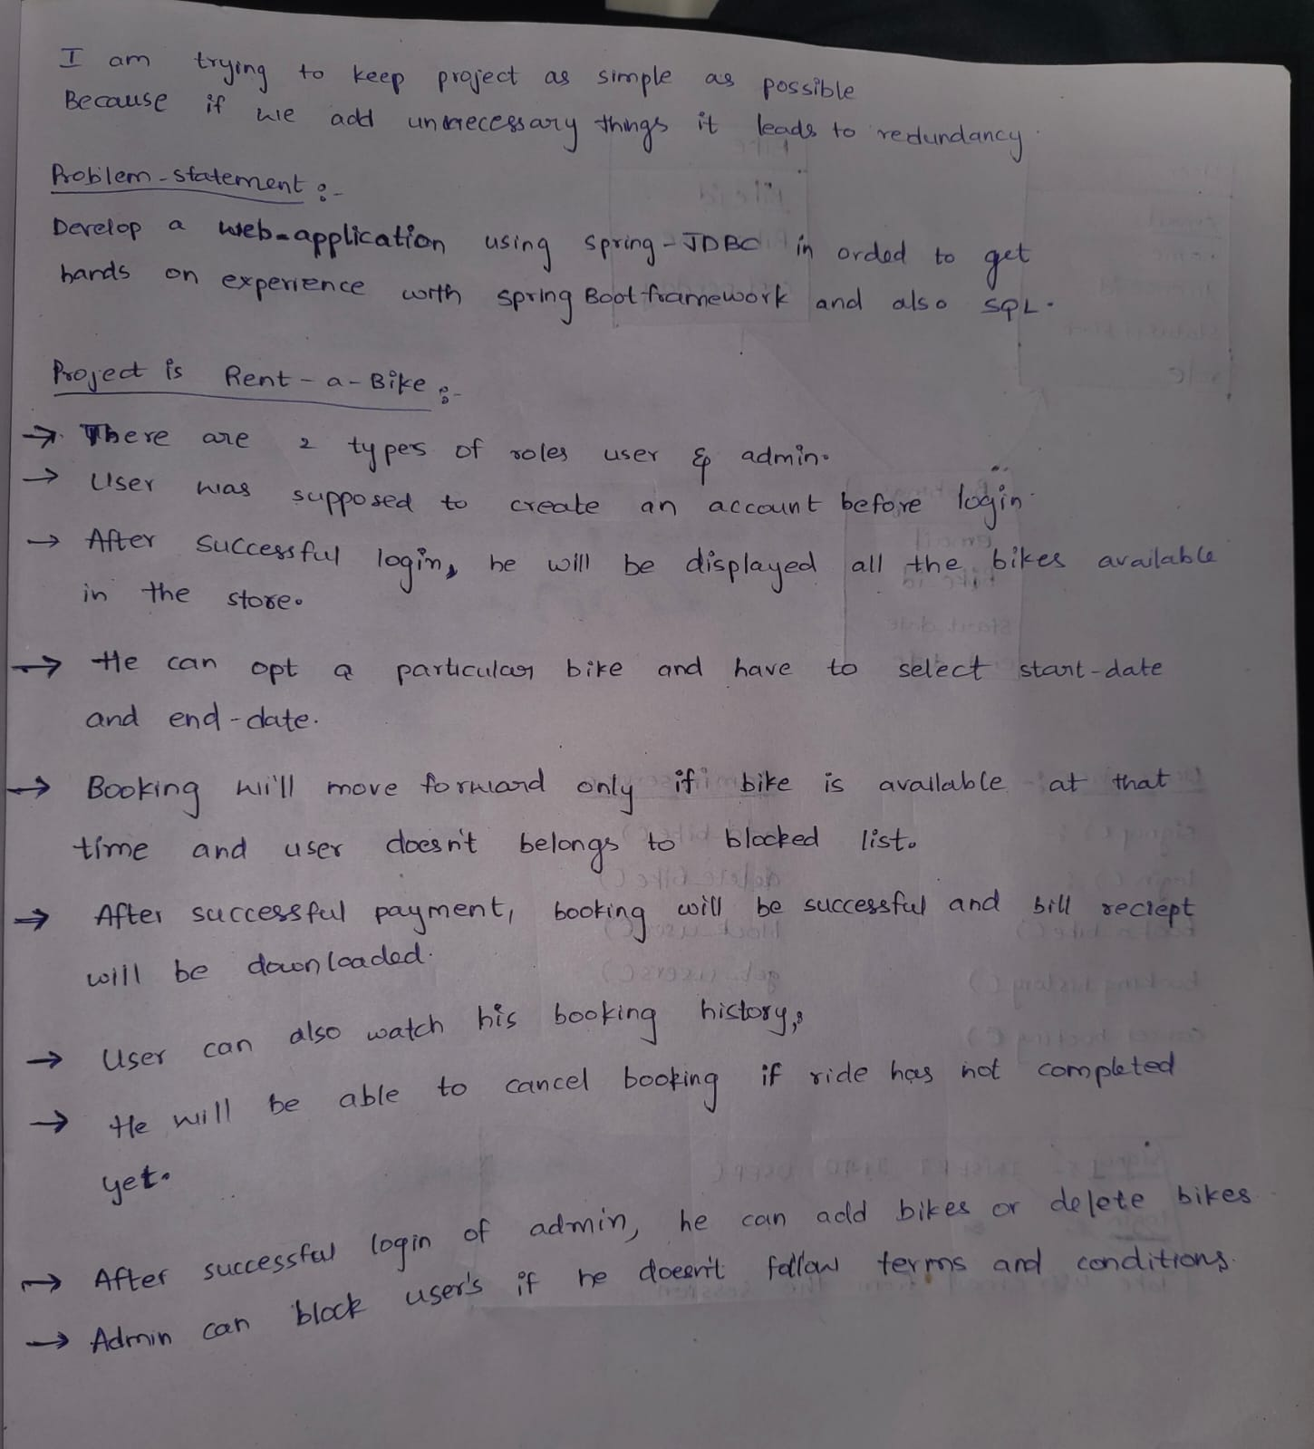

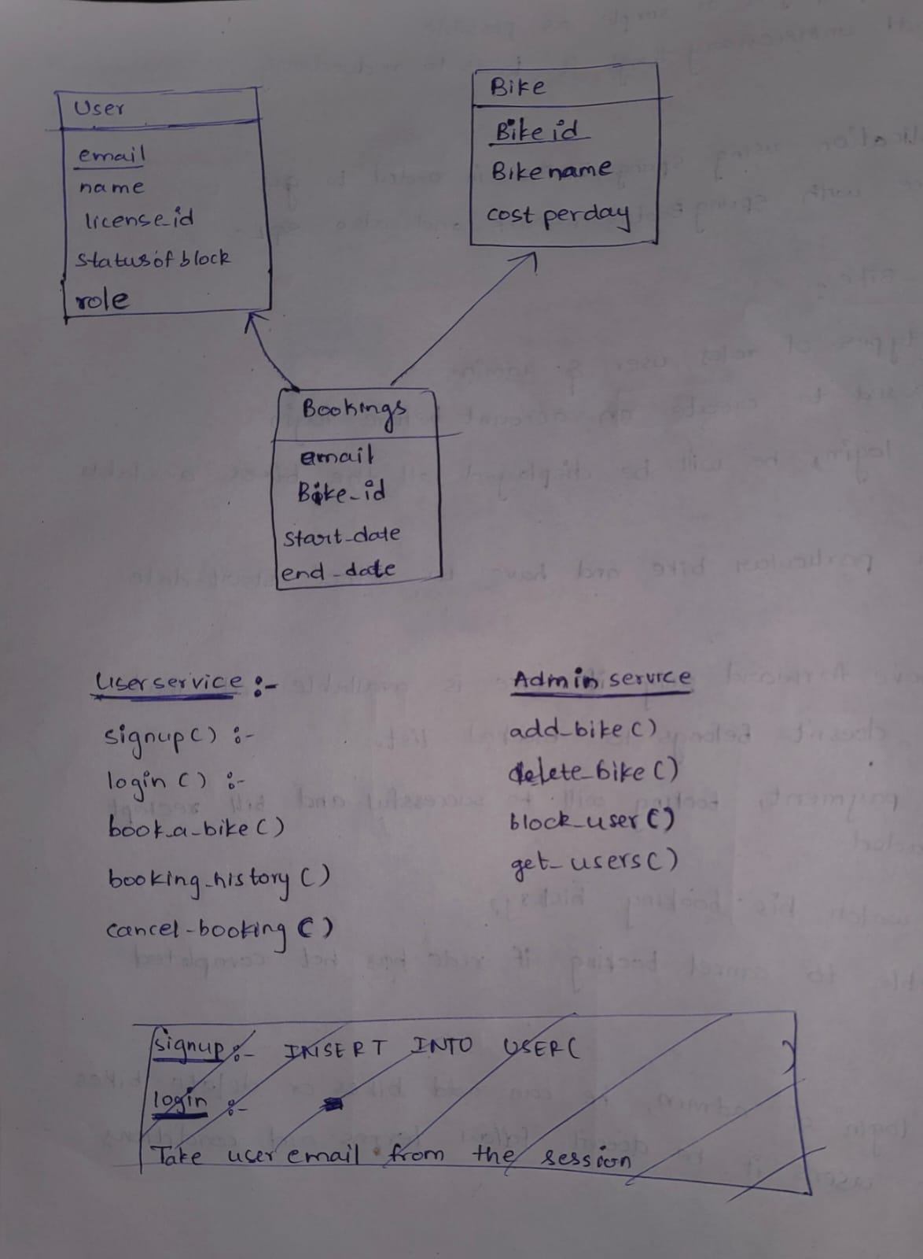

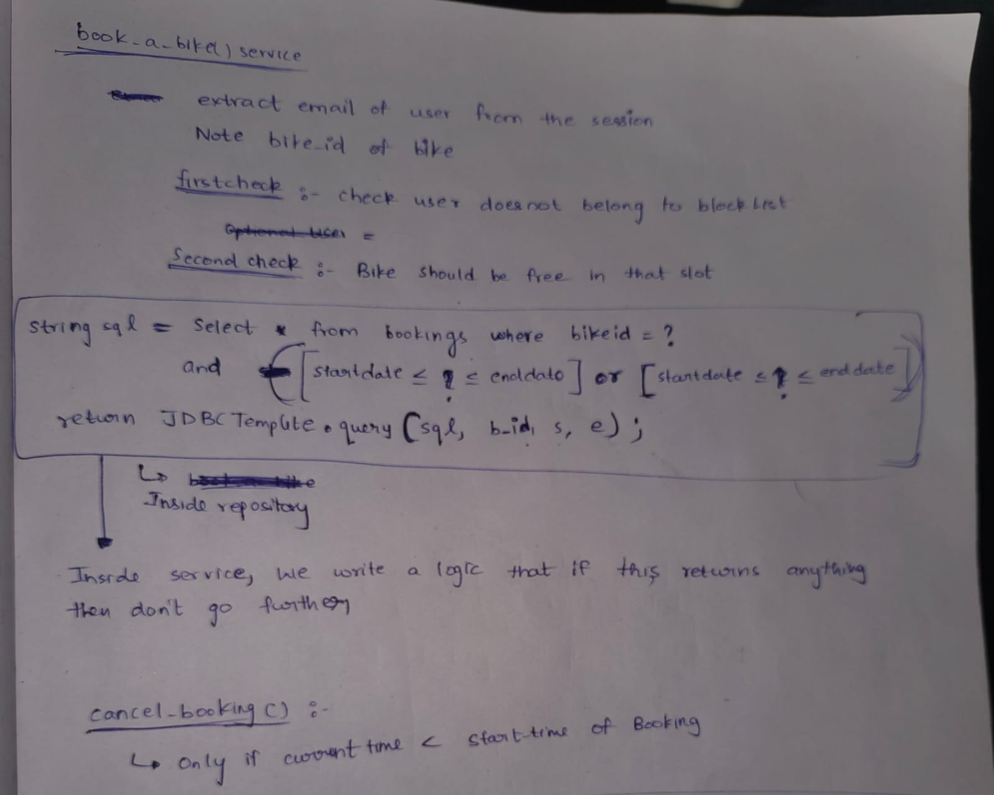

Razorpay:
when you click pay button
In javascript code we will send all the order details, razorpay related keys as parameters to razorpay.client()
This will return a transaction id.
Using this transaction id we will create an object and send as parameter to razorpay.open() then a pop up for the payment is opened.

Difficulties:
My part in the project is to work on tables and write SQL queries. So I didn’t face any difficulty.

